## **Exercise - Volumes**

###### **Name: Haffiz Hissham**

###### **Date: 21 September 2024**

#### **Q1**

Create a new PersistentVolumeClaim:

✑ Name: pv-volume

✑ Class: csi-hostpath-sc

✑ Capacity: 10Mi

Create a new Pod which mounts the PersistentVolumeClaim as a volume:

✑ Name: web-server

✑ Image: nginx

✑ Mount path: /usr/share/nginx/html

Configure the new Pod to have ReadWriteOnce access on the volume.

Finally, using kubectl edit or kubectl patch expand the PersistentVolumeClaim to a capacity of 70Mi and record that change.

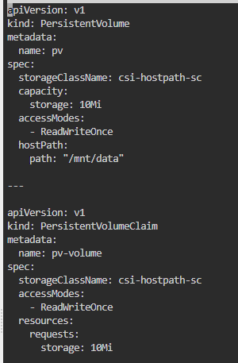

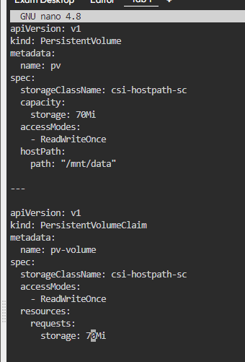

#### **Q2**

schedule a pod as follows:

✑ name: nginx-kusc00401

✑ image: nginx

✑ node selector: disk=ssd

#### **Q3**

Create a new pod called web-pod with image busy box

Allow the pod to be able to set system_time

The container should sleep for 3200 seconds

#### **Q4**

Create a new PersistentVolume named safari-pv. It should have a capacity of 2Gi, accessMode ReadWriteOnce, hostPath /Volumes/Data and no storageClassName defined.

Next create a new PersistentVolumeClaim in Namespace project-tiger named safari-pvc . It should request 2Gi storage, accessMode ReadWriteOnce and should not define a storageClassName. The PVC should bound to the PV correctly.

Finally create a new Deployment safari in Namespace project-tiger which mounts that volume at /tmp/safari-data. The Pods of that Deployment should be of image httpd:2.4.41-alpine.

